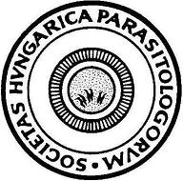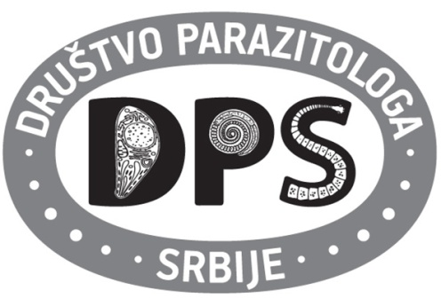

SECOND BILATERAL HUNGARIAN AND SERBIAN PARASITOLOGY SOCIETIES

MEETING

October 14, 2016

Venue: Szeged Zoo, Learning Center

PROGRAM:

10:00-11:30 Get together and refreshment

11:30-13:30 Round table

Introductory presentations and moderators:
Róbert Farkas and Olgica Djurković-Djaković

- Róbert Farkas, President of the Hungarian Society for Parasitology: Current information about teaching and research in veterinary parasitology in Hungary
- István Kucsera, member of the board of the Hungarian Society for Parasitology: Some information about human parasitology in Hungary
- Olgica Djurković-Djaković, President of the Serbian Society for Parasitology: Parasitology teaching and research in Serbia. SWOT analysis

Scientific lectures

- Snežana Tomanović, Institute for Medical Research, University of Belgrade, Serbia: Medical entomology in Serbia. Wild animals as hosts for anthropophilic tick species
- Sándor Szekeres, University of Veterinary Medicine Budapest, Hungary: Tick-borne pathogens in Hungary: Rural vs urban habitats

13:30 Lunch and visit of the ZOO

18:00 End of meeting

